Appendix B
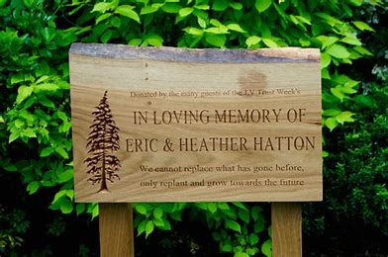
Memorial for Mr Mansfield
I have spoken to the family and they were overjoyed that we are considering this memorial marker for their Father, they would like to pass on their thanks to you all.

They would like if possible for it to be situated close to where he lived which was Sunny Bank, and they have suggested the corner by the old police house. They have also said that they would much prefer a tree than a bench if possible, however they are very grateful of us considering either to mark the memory of their father.
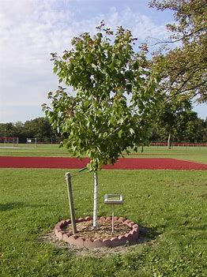
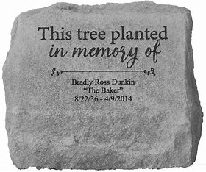
I’ve copied an example of an idea of a memorial tree and some memorial plaques just to give an idea of the kind of thing we are looking for.
Lucy

